Danish Championship
INVITATION

Wedensday / Onsdag – 14 august 2024 : Semifinals 17:00
Saturday / Lørdag - 17 august 2024 : Finals 14:00

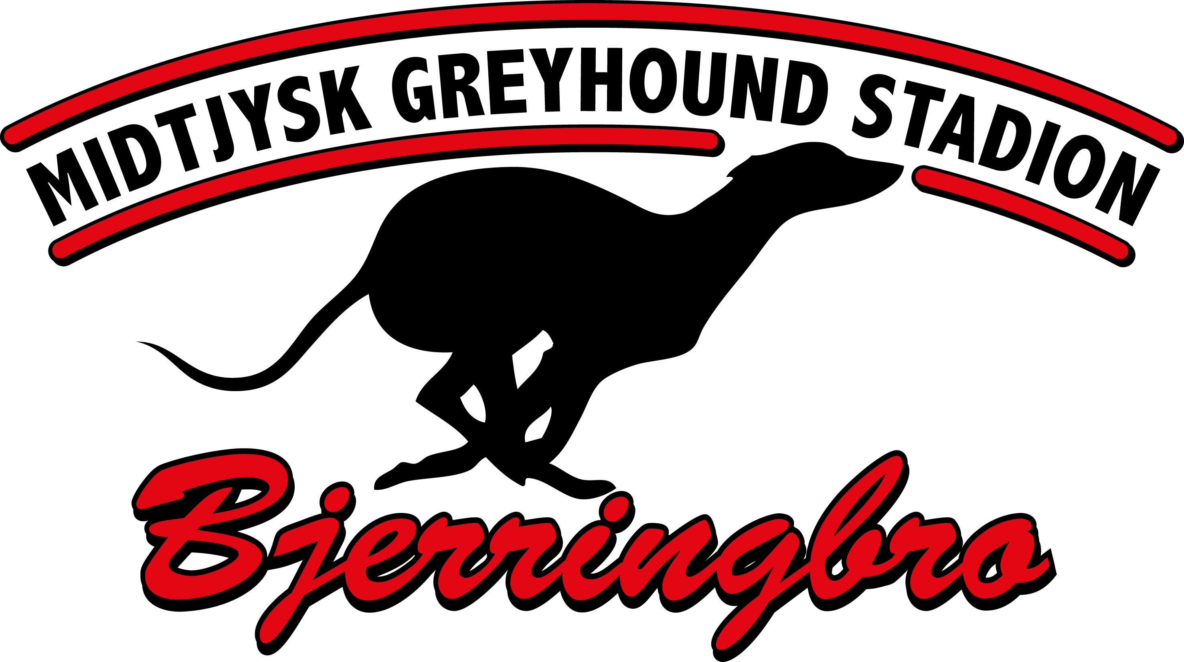
Greyhound Sprint 305 m. – Bitches and dogs
Greyhound Middle 535 m. – Bitches and dogs
Greyhound Stayer 763 m. – Mixed
Greyhound Puppy* 305 m. / 535 m. – Mixed
Greyhound Veteran** 305 m. – Mixed
Greyhound Danish Bred 305 m. / 535 m. – Mixed

Whippet Sprint 305 m. – Bitches and dogs
Whippet Middle 535 m. – Bitches and dogs
Whippet Stayer 763 m. – Mixed
Whippet Puppy* 305 m. – Mixed
Whippet Veteran** 305 m. – Mixed
Whippet Danish Bred 305 m. – Mixed
*The dogs are puppy for a period of 2 years from and including the month of birth.
**The dogs are veteran from 5 years and including the month of birth.

Other breeds/mixed breeds 305 m. / 535 m. – Mixed

Races will be mixed if there are less than 4 entries in each cat. and we need at least 4 dogs per race.
Please remember always to enter with an alternative race/distance.

Entry fee / startgebyr: 35 EUR / 260 DKK
Winners jackets, ribbons, trophies & suprice presents for all finals.
There will be prize money in all races. Every entry fee go uncut to the prize money + the club will add 27 EUR / 200 DKK per dog entered. The final prize money depends on how many entries per class/race.

Entries close / senest tilmelding: Sunday / søndag – 4. August 2024, 20:00
Entries / tilmelding til: Rikke Bankov - trapper910@gmail.com
The entry is financially binding.
---------------------------------------------------------------------------------
Graded races – only 17 August 2024
Entry fee / startgebyr: 14 EUR / 110 DKK
Ribbon for all winners + suprice presents.
Every entry fee go uncut to the prize money.

Entries close / senest tilmelding: Friday / fredag – 4. August 2024, 20:00
Entries / tilmelding til: Rikke Bankov - trapper910@gmail.com
The entry is financially binding.
---------------------------------------------------------------------------------
All dogs entered must have a valid FCI or CGRC racing license.

All dogs must be present at the track from one hour before first race to 10 minutes after last race.
Races start at 17:00 on Wednesday and 14:00 on Saturday.

Race cards will be published on www.midtjyskgreyhoundstadion.dk and our Facebook page latest 7. aug. 2024

Looking forward to see you all in Bjerringbro, Denmark.
DANISH CHAMPIONSHIP - Midtjysk Greyhound Stadion - 14 august & 17 august 2024

ENTRY FORM / TILMELDINGSFORMULAR
Name |  | Breed
Preferred race/distance |  | Alternative race/distance | First choise:  Second choise:

Sire |  | Dam

Birthday |  | Sex |  | Color

Box/trap:  I (inside 1-2) M/I (box 3-1)  M (middle 3-4) M/O (box 4-6) W (wide 5-6) |  | Chip/ID

Trainer |  | Owner
Latest 3 results: Distance / Result / Time

OWNER:
ADDRESS:
TEL / E-MAIL:

Camping – Midtjysk Greyhound Stadion
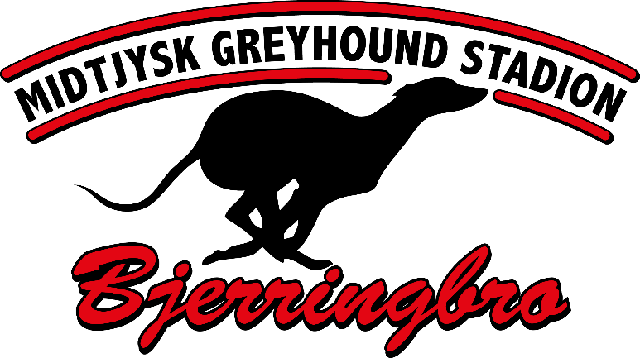

It´s possible for camping. Prize: 10 EUR / DAY

Contact: Rikke Bankov trapper910@gmail.com

