
CGRC European Championship
INVITATION

Wedensday / Onsdag – 9 august 2023 : Semifinals 17:00
Saturday / Lørdag - 12 august 2023 : Finals & Consolations 14:00

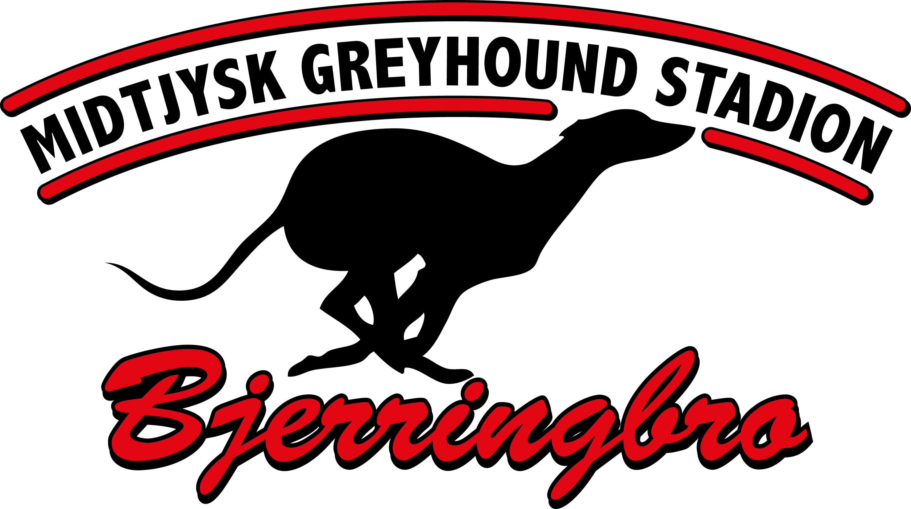
Greyhound Sprint 303 m. – Bitches and dogs
Greyhound Middle 524 m. – Bitches and dogs
Greyhound Stayer 750 m. – Mixed
Greyhound Puppy* 303 m. / 524 m. – Mixed
Greyhound Veteran** 303 m. – Mixed

Whippet Sprint 303 m. – Bitches and dogs
Whippet Middle 524 m. – Bitches and dogs
Whippet Stayer 750 m. – Mixed
Whippet Puppy* 303 m. / 524 m. – Mixed
Whippet Veteran** 303 m. – Mixed
*The dogs are puppy for a period of 2 years from and including the month of birth.
**The dogs are veteran from 5 years and including the month of birth.

Other breeds/mixed breeds Sprint 303 m. – Mixed
Other breeds/mixed breeds Middle 524 m. – Mixed
Other sighthounds Stayer 750 m. – Mixed

Races will be mixed if there are less than 3 entries in each cat.
Please remember always to enter with an alternative race/distance.

Entry fee / startgebyr: 35 EUR / 260 DKK
Winners jackets, ribbons, trophies & suprice presents for all finals & consolations.
There will be prize money in all EC races. Every entry fee go uncut to the prize money + the club will add money depending on how many entries.

Entries close / senest tilmelding: Friday / fredag – 28 july 2023, 20:00
Entries / tilmelding til: Rikke Bankov - trapper910@gmail.com
The entry is financially binding.
---------------------------------------------------------------------------------
Graded races – only 12 August 2023
Entry fee / startgebyr: 20 EUR / 160 DKK
Ribbon for all winners + suprice presents.
Every entry fee go uncut to the prize money.

Entries close / senest tilmelding: Friday / fredag – 28 july 2023, 20:00
Entries / tilmelding til: Rikke Bankov - trapper910@gmail.com
The entry is financially binding.
---------------------------------------------------------------------------------
All dogs entered must have a valid racing license.

All dogs must be present at the track from one hour before first race to 10 minutes after last race.
Races start at 17:00 on Wednesday and 14:00 on Saturday.

Race cards will be published on www.midtjyskgreyhoundstadion.dk and our Facebook page latest 4 aug. 2023

Looking forward to see you all in Bjerringbro, Denmark.
EUROPEAN CHAMPIONSHIP - Midtjysk Greyhound Stadion - 9 august & 12 august 2023

ENTRY FORM / TILMELDINGSFORMULAR
Name |  | Breed
Preferred race/distance |  | Alternative race/distance

Sire |  | Dam

Birthday |  | Sex |  | Color

Box/trap: I (inside) M (middle) W (wide) |  | Chip/ID

Breeder |  | Trainer / Owner
Latest 3 results: Distance / Result / Time

OWNER:
ADDRESS:
TEL / E-MAIL:

Camping – Midtjysk Greyhound Stadion 9 – 12 august 2023
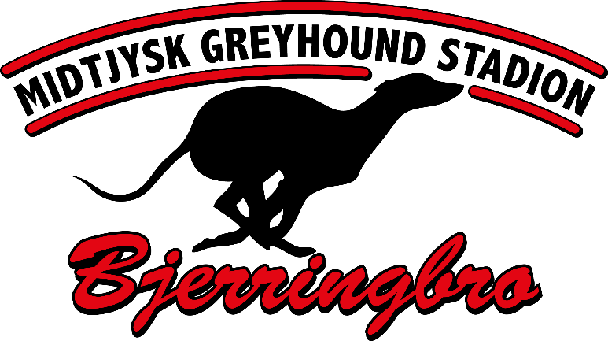

It´s possible for camping. Prize: 10 EUR / DAY

Contact: Rikke Bankov trapper910@gmail.com

